Algebra 2 Midterm Exam
Name:
Directions: Use what you have learned in this course to answer the following questions. Justify your responses completely. Each question is worth 5 points.
1. Solve for n: –6(n – 8) = 4(12 – 5n) + 14n.

2. For f(x) = 2|x+3| – 5, name the type of function and describe each of the three transformations from the parent function f(x) = |x|.

3. Determine whether f(x) = –5$x^{2}$ – 10x + 6 has a maximum or a minimum value. Find that value and explain how you know.

4. The median weekly earnings for American workers in 1990 was $412 and in 1999 it was $549. Calculate the average rate of change between 1990 and 1999.

5. Find the roots of the parabola given by the following equation.

2x²+ 5x - 9 = 2x

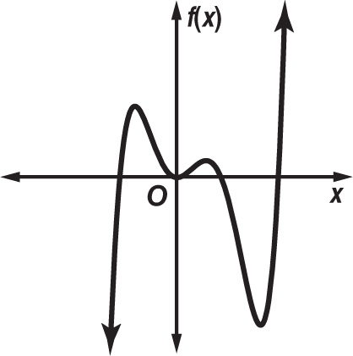
6. Describe the end behavior and determine whether the graph represents an odd-degree or an even-degree polynomial function. Then state the number of real zeros.

7. GEOMETRY Recall the formula for finding the area of a rectangle. Define a variable for the width and set up an equation to find the dimensions of a rectangle that has an area 144 square inches, given that the length is 10 inches longer than its width.

DIMENSIONS:
Length: Width:

8. The amount f(t) of a certain medicine, in milligrams, in a patient’s bloodstream t minutes after being taken is given by f(t) = $\frac{60t}{t^{2}+46}$ .
Find the amount of medicine in the blood after 20 minutes.

9. Graph f(x) = x² + 2x - 3, label the function’s x-intercepts, y-intercept and vertex with their coordinates. Also draw in and label the axis of symmetry.
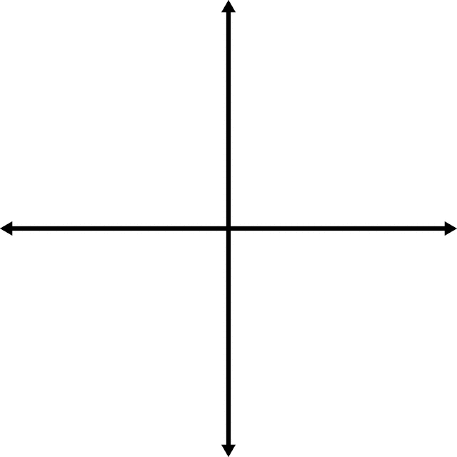
10. Determine whether the relation shown is a function. Explain how you know.
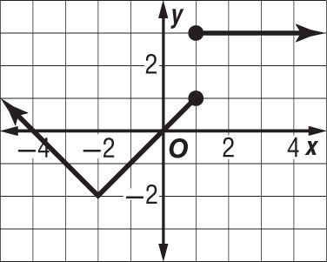
11. Solve the inequality and graph the solution on a number line.

–3(5y – 4) ≥ 17

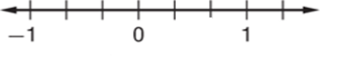

12. Assume that the wooden triangle shown is a right triangle.
​​
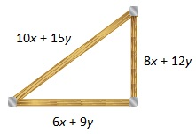
a. Write an equation using the Pythagorean Theorem and the measurements provided in the diagram.

Hint: (leg 1)² + (leg 2)² = (hypotenuse)²

b. Transform each side of the equation to determine if it is an identity.

13. Use long division or synthetic division to find the quotient of $\frac{{2x}^{3} + x^{2} + 1 }{x + 1}$.

14. Simplify (9$k^{6}$ + 8$k^{4}$ – 6$k^{2}$)(4$k^{2}$ – 5).

15. Find the inverse of h(x) = $\frac{2x + 6}{5}$.

16. If f(x) = 2x – 1 and g(x) = $x^{2}$ – 2, find [g ◦ f](x).

17. Graph the function y = $\sqrt{x + 4}$ – 2. Then state the domain and range of the function.
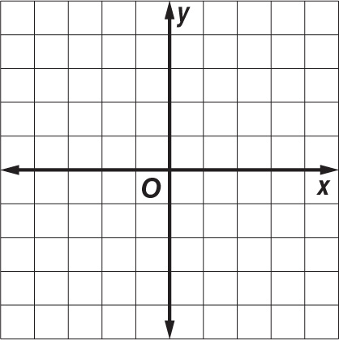

Domain:

Range:

18. If f(x) = 3x² – 2 and g(x) = 4x + 2, what is the value of (f + g)( 2) ?

The price of a sweatshirt at a local shop is twice the price of a pair of shorts. The price of a T-shirt at the shop is $4 less than the price of a pair of shorts. Brad purchased 3 sweatshirts, 2 pairs of shorts, and 5 T-shirts for a total cost of $136.

19. Let w represent the price of one sweatshirt, t represent the price of one T-shirt, and h represent the price of one pair of shorts. Write a system of three equations that represents the prices of the clothing.

20. Solve the system. Find the cost of each item.

